Honor Your Father and Mother

Ephesians 6:2-3 “Honor your father and mother”—which is the first commandment with a promise— “that it may go well with you and that you may enjoy long life on the earth.”

If we regard [parents] with reference to their noses, eyes, skin and hair, flesh and bones, they look no different from [everyone else]. Someone might come and say, “Why should I think more of this person than of others?” But because the commandment is added, “You shall honor father and mother,” I see another man, adorned and clothed with the majesty and glory of God. The commandment, I say, is the golden chain about his neck, yes, the crown on his head, which shows me how and why I should honor this particular flesh and blood .
—Large Catechism 4, 20

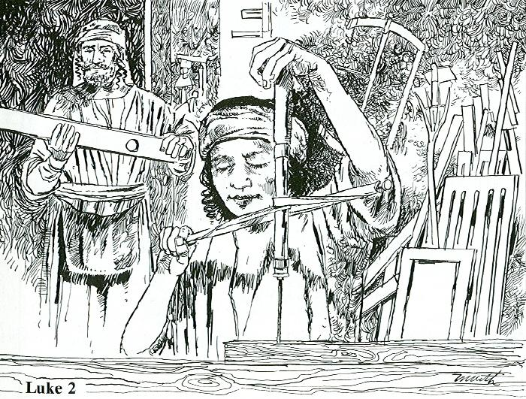

Read Luke 2:41-52
1. What feast did they go to celebrate?

2. Why did Luke mention that Jesus was 12 years old when they went to Jerusalem?

3. Where was Jesus when Mary and Joseph thought he was lost?

4. How did Jesus answer his parents when they questioned him?

5. How does the picture help us understand verse 51?

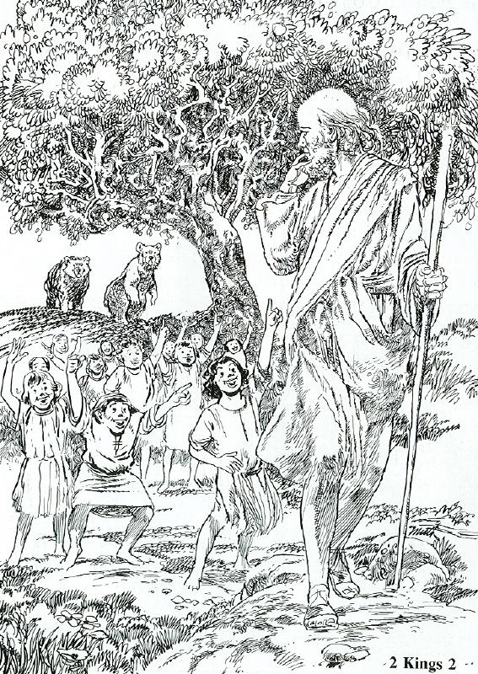
Read 2 Kings 2:1-18, 23-25
1. How does the prophet Elisha fit the command to "honor your father and mother"?

2. What did the youths do to the prophet?

3. How did that make Elisha feel?
(picture & verse 24)

4. How did the youths break the 4th commandment?

5. What was the consequence of their actions?

Leviticus 19:32 Rise in the presence of the aged, show respect for the elderly and revere your God. I am the LORD.

Proverbs 30:17 The eye that mocks a father, that scorns obedience to a mother, will be pecked out by the ravens of the valley, will be eaten by the vultures.

